**Methods of LinkedHashSet**

Here, **E** is the type of element stored.

| **METHOD** | **DESCRIPTION** |
| --- | --- |
| spliterator() | Creates a late-binding and fail-fast Spliterator over the elements in this set. |

**Methods declared in class java.util.AbstractSet**

| **METHOD** | **DESCRIPTION** |
| --- | --- |
| [equals(Object o)](https://www.geeksforgeeks.org/abstractset-equals-method-in-java-with-examples/?ref=rp) | Compares the specified object with this set for equality. |
| [hashCode()](https://www.geeksforgeeks.org/abstractset-hashcode-method-in-java-with-examples/?ref=rp) | Returns the hash code value for this set. |
| [removeAll(Collection c)](https://www.geeksforgeeks.org/abstractset-removeall-method-in-java-with-examples/?ref=rp) | Removes from this set all of its elements that are contained in the specified collection (optional operation). |

**Methods declared in class java.util.AbstractCollection**

| **METHOD** | **DESCRIPTION** |
| --- | --- |
| [addAll​(Collection<? extends E> c)](https://www.geeksforgeeks.org/abstractcollection-addall-method-in-java-with-examples/) | Adds all of the elements in the specified collection to this collection (optional operation). |
| [containsAll​(Collection<?> c)](https://www.geeksforgeeks.org/abstractcollection-containsall-method-in-java-with-examples/) | Returns true if this collection contains all of the elements in the specified collection. |
| [retainAll​(Collection<?> c)](https://www.geeksforgeeks.org/abstractcollection-retainall-method-in-java-with-examples/) | Retains only the elements in this collection that are contained in the specified collection (optional operation). |
| [toArray()](https://www.geeksforgeeks.org/abstractcollection-toarray-method-in-java-with-examples/) | Returns an array containing all of the elements in this collection. |
| [toArray​(T[] a)](https://www.geeksforgeeks.org/abstractcollection-toarray-method-in-java-with-examples/) | Returns an array containing all of the elements in this collection; the runtime type of the returned array is that of the specified array. |
| [toString()](https://www.geeksforgeeks.org/abstractcollection-tostring-method-in-java-with-examples/) | Returns a string representation of this collection. |

**Methods declared in interface java.util.Collection**

| **METHOD** | **DESCRIPTION** |
| --- | --- |
| parallelStream() | Returns a possibly parallel Stream with this collection as its source. |
| removeIf(Predicate<? super  E> filter) | Removes all of the elements of this collection that satisfy the given predicate. |
| stream() | Returns a sequential Stream with this collection as its source. |

**Methods declared in class java.util.HashSet**

| **METHOD** | **DESCRIPTION** |
| --- | --- |
| [add(E e)](https://www.geeksforgeeks.org/hashset-add-method-in-java/) | Adds the specified element to this set if it is not already present. |
| [clear()](https://www.geeksforgeeks.org/hashset-clear-method-in-java/) | Removes all of the elements from this set. |
| [clone()](https://www.geeksforgeeks.org/hashset-clone-method-in-java/) | Returns a shallow copy of this HashSet instance: the elements themselves are not cloned. |
| [contains(Object o)](https://www.geeksforgeeks.org/hashset-contains-method-in-java/) | Returns true if this set contains the specified element. |
| [isEmpty()](https://www.geeksforgeeks.org/hashset-isempty-method-in-java/) | Returns true if this set contains no elements. |
| [iterator()](https://www.geeksforgeeks.org/hashset-iterator-method-in-java/) | Returns an iterator over the elements in this set. |
| [remove(Object o)](https://www.geeksforgeeks.org/hashset-remove-method-in-java/) | Removes the specified element from this set if it is present. |
| [size()](https://www.geeksforgeeks.org/hashset-size-method-in-java/) | Returns the number of elements in this set (its cardinality). |

**Methods declared in interface java.lang.Iterable**

| **METHOD** | **DESCRIPTION** |
| --- | --- |
| [forEach(Consumer<? super](https://www.geeksforgeeks.org/iterable-foreach-method-in-java-with-examples/)  [T> action)](https://www.geeksforgeeks.org/iterable-foreach-method-in-java-with-examples/) | Performs the given action for each element of the Iterable until all elements have been processed or the action throws an exception. |

**Methods declared in interface java.util.Set**

| **METHOD** | **DESCRIPTION** |
| --- | --- |
| [add(element)](https://www.geeksforgeeks.org/set-add-method-in-java-with-examples/) | This method is used to add a specific element to the set. The function adds the element only if the specified element is not already present in the set else the function returns False if the element is already present in the Set. |
| [addAll(Collection c)](https://www.geeksforgeeks.org/set-addall-method-in-java-with-examples/) | This method is used to append all of the elements from the mentioned collection to the existing set. The elements are added randomly without following any specific order. |
| [clear()](https://www.geeksforgeeks.org/set-clear-method-in-java-with-examples/) | This method is used to remove all the elements from the set but not delete the set. The reference for the set still exists. |
| [contains(element)](https://www.geeksforgeeks.org/set-contains-method-in-java-with-examples/) | This method is used to check whether a specific element is present in the Set or not. |
| [containsAll(Collection c)](https://www.geeksforgeeks.org/set-containsall-method-in-java-with-examples/) | This method is used to check whether the set contains all the elements present in the given collection or not. This method returns true if the set contains all the elements and returns false if any of the elements are missing. |
| [hashCode()](https://www.geeksforgeeks.org/set-hashcode-method-in-java-with-examples/) | This method is used to get the hashCode value for this instance of the Set. It returns an integer value which is the hashCode value for this instance of the Set. |
| [isEmpty()](https://www.geeksforgeeks.org/set-isempty-method-in-java-with-examples/#:~:text=isEmpty()%20method%20is%20used,empty%20otherwise%20it%20returns%20False.&text=Return%20Value%3A%20The%20method%20returns,is%20empty%20else%20returns%20False.) | This method is used to check whether the set is empty or not. |
| [iterator()](https://www.geeksforgeeks.org/set-iterator-method-in-java-with-examples/) | This method is used to return the iterator of the set. The elements from the set are returned in random order. |
| [remove(element)](https://www.geeksforgeeks.org/set-remove-method-in-java-with-examples/) | This method is used to remove the given element from the set. This method returns True if the specified element is present in the Set otherwise it returns False. |
| [removeAll(collection)](https://www.geeksforgeeks.org/set-removeall-method-in-java-with-examples/) | This method is used to remove all the elements from the collection which are present in the set. This method returns true if this set changed as a result of the call. |
| [retainAll(collection)](https://www.geeksforgeeks.org/set-retainall-method-in-java-with-example/) | This method is used to retain all the elements from the set which are mentioned in the given collection. This method returns true if this set changed as a result of the call. |
| [size()](https://www.geeksforgeeks.org/set-size-method-in-java-with-example/) | This method is used to get the size of the set. This returns an integer value which signifies the number of elements. |
| [toArray()](https://www.geeksforgeeks.org/set-toarray-method-in-java-with-example/) | This method is used to form an array of the same elements as that of the Set. |
| toArray​(T[] a) | Returns an array containing all of the elements in this set; the runtime type of the returned array is that of the specified array. |

Following is the difference between [LinkedHashMap](https://www.geeksforgeeks.org/linkedhashmap-class-java-examples/) and LinekdHashSet:

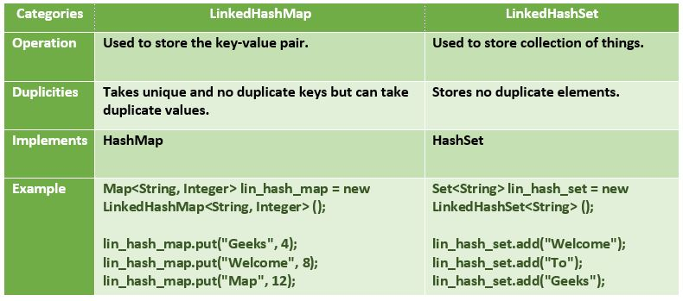

**Note:** Keeping the insertion order in both LinkedHashmap and LinkedHashset have additional associated costs, both in terms of spending additional CPU cycles and needing more memory. If you do not need the insertion order maintained, it is recommended to use the lighter-weight [HashSet](http://quiz.geeksforgeeks.org/hashset-in-java/) and [HashMap](https://www.geeksforgeeks.org/hashmap-treemap-java/) instead.